**Lab-04**

**Lab Task(s):**

Exercise

1.    Write a query to lists the number of employees in each department.

**SELECT departments.department_name as department, COUNT(employees.employee_id) as number_of_employees**

**FROM departments**

**LEFT JOIN employees ON departments.department_id = employees.department_id**

**GROUP BY departments.department_id;**

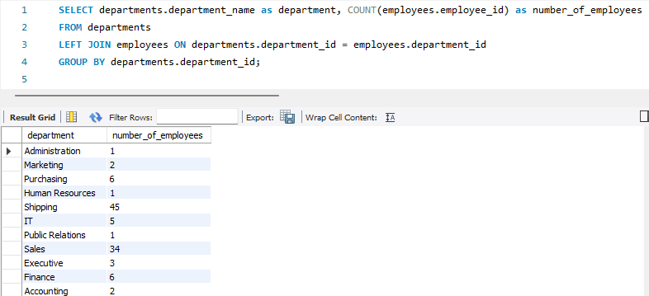

2.    Write a query to display the department id where at least 5 employees should be in each department.

**SELECT department_id**

**FROM employees**

**GROUP BY department_id**

**HAVING COUNT(*) >= 5;**

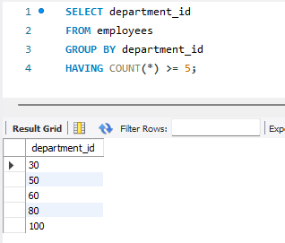

3.    Write a query to display all columns of those employees who has first name is unique.

**SELECT \***

**FROM employees**

**WHERE first_name IN (**

**SELECT first_name**

**FROM employees**

**GROUP BY first_name**

**HAVING COUNT(*) = 1**

**);**

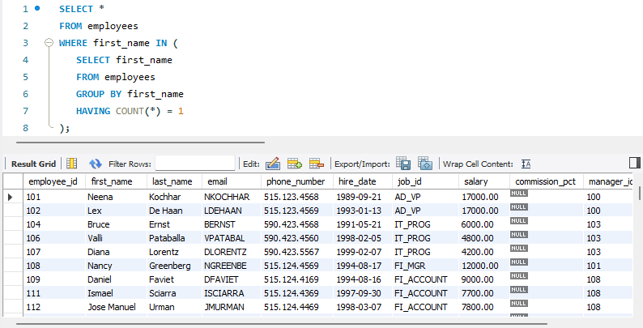

4.    Write a SQL query to get name of employees containing exactly four characters.

**SELECT concat(first_name, " " , last_name) as name_**

**FROM employees**

**WHERE CHAR_LENGTH(concat(first_name, last_name)) = 4;**

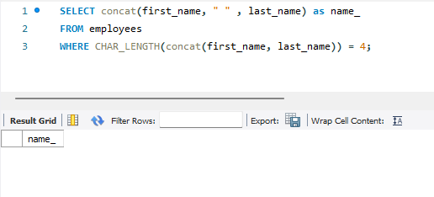

5.    Write a query to display the list of employee names that have letters ‘LA’ in their names.

**SELECT concat(first_name, " ", last_name) as Employee_Name**

**FROM employees**

**WHERE concat(first_name, " ", last_name) LIKE '%LA%';**

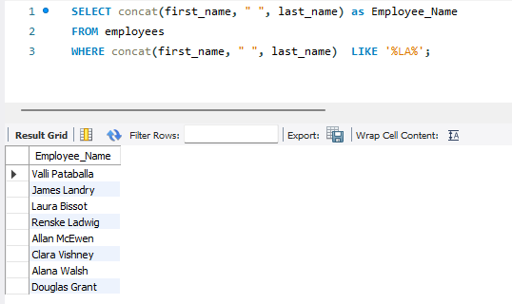

6.    Write a query to display names of those employees whose first name starts with ‘A’ and ends with ‘N’.

**SELECT concat(first_name, " ", last_name) as Employee_Name**

**FROM employees**

**WHERE concat(first_name, " ", last_name) LIKE 'A%N';**

7.    Write a query to display first names of all employees that end with alphabet ‘N’.

**SELECT first_name**

**FROM employees**

**WHERE first_name LIKE '%N';**

8.    Write a query to display FIRST_NAME, LASTNAME of all employees whose first name starts with letter ‘A’.

**SELECT concat(first_name, " ", last_name) as Employee_Name**

**FROM employees**

**WHERE first_name LIKE 'A%';**

9.    Write a query to display the number of employees with the same job.

**SELECT job_title, COUNT(*) as number_of_employees**

**FROM jobs**

**GROUP BY job_title;**

10. Display the manager number and the salary of the lowest paid employee of that manager. Exclude anyone whose manager is not known. Exclude any groups where the minimum salary is 2000. Sort the output is descending order of the salary.

**SELECT e.manager_id AS manager_number, MIN(e.salary) AS lowest_salary**

**FROM employees e**

**WHERE e.manager_id IS NOT NULL**

**GROUP BY e.manager_id**

**HAVING MIN(e.salary) > 2000**

**ORDER BY lowest_salary DESC;**

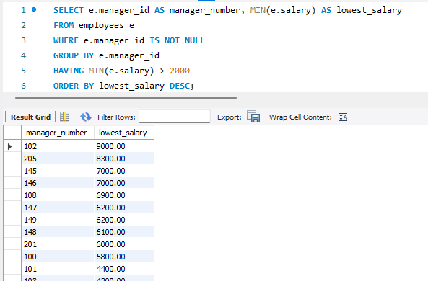

11. Display the total number of employees who have no commission.

**SELECT COUNT(*) AS number_of_employees**

**FROM employees**

**WHERE commission_pct IS NULL;**

12. Write a query to display FIRST_NAME, LASTNAME of all employees whose first name ends with small ‘t’.

**SELECT concat(first_name, " ", last_name)**

**FROM employees**

**WHERE first_name LIKE '%T';**

